Rating down (or not) for imprecision: Challenges and possible solution when one targets the null and the point estimate turns out to be very close to the null
- The challenge of a point estimate near the null
Core GRADE users who choose the null typically do so at least in part to avoid the value judgements involved in specifying an MID. When the point estimate is not close to the null, they will rate their certainty in a true underlying benefit or harm. When the point estimate is close to the null (b in Figure 1), however, it becomes counterintuitive to rate certainty in a true benefit or harm. The reason is that the most likely truth is little or no effect, and it is therefore most appropriate to rate certainty in that inference.¹
Figure 1. Target of the certainty rating with respect to the null. If the point estimate falls close to the null as in situation b Core GRADE users should consider revising the target of the certainty rating from a non-zero effect to little to no effect. If Core GRADE users are confident that the point estimate is not close to the null (i.e., larger than the MID, as in situation a), they will continue to rate certainty in a non-zero effect.
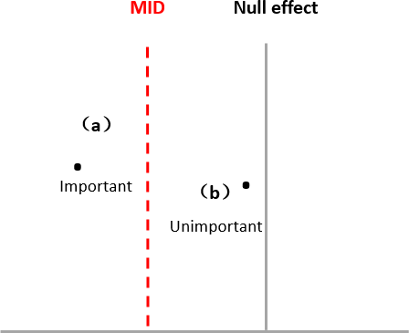
Core GRADE users then face the challenge of deciding what they mean by “little or no effect”. The answer is “an unimportant effect” or “an effect less than the MID” (b in Figure 1). They are then in the position they were hoping to avoid: considering peoples’ values and making the judgement of what their target audience would consider an MID.

Deciding whether to rate down for imprecision
Having decided they are now in the position of rating their certainty in little or no effect, it appears on the surface that they must choose a specific single value of the MID. They will then rate down certainty for
imprecision if the confidence interval crosses the threshold of the MID for benefit or the MID for harm (b or c in Figure 2) or both (d in Figure 2). If the CI crosses neither threshold they will not rate down for imprecision (a in Figure 2).

Figure 2. Rating certainty in little or no effect. If the CI does not cross the MID (situation a), Core GRADE users will not rate down for imprecision; if crosses, they will rate down (situation b, c, d).
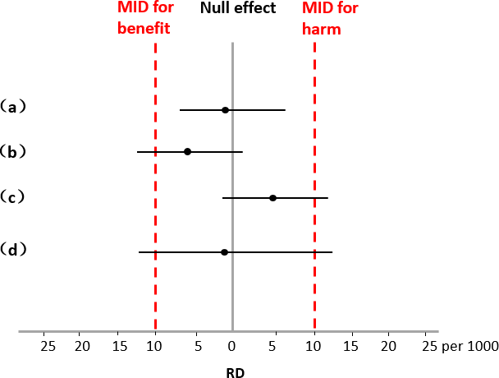
It turns out, however, that Core GRADE users choosing the null as their threshold may avoid having to choose a specific MID. In doing so, they avoid the most challenging of the value judgements they were hoping to forego.

Ameliorating the challenge of choosing an MID
Judgments regarding the MID will be less onerous for Core GRADE users if they are required only to consider a range in which the MID might lie rather than a specific MID. The following discussion demonstrates how
this is possible.
Core GRADE users who have chosen the null as a threshold and face a point estimate near the null may avoid specifying an exact value for the MID by considering the boundaries of the CI. If those boundaries are clearly within the range that the MID lies (i.e. the ends of the confidence interval represent a lower value than the MID), they needn’t rate down for imprecision. If the boundary of the CI is clearly greater than the range in which the MID lies (i.e. one or both ends of the confidence represent a higher value than the MID) they will rate down for imprecision.
For instance, consider a hypothetical example in which the lower boundary of the CI is a reduction in
mortality of 50 per 1000 (Figure 3). Without specifying that the threshold of importance is 5, 10, or 20 or 40 in 1,000, all would agree this magnitude represents an important benefit and thus crosses the threshold -
wherever exactly that threshold lies. Therefore, without specifying a single specific value of the confidence interval, one would certainly rate down for imprecision.

Figure 3. A hypothetical example of imprecision judgment without explicitly specifying an MID threshold in a meta-analysis on mortality. A judgment of whether the boundary of the confidence interval is greater or less than the MID is required. The lower boundary of the confidence interval (a reduction in mortality of 50 per 1000) represents an important benefit whether the MID is a reduction of 5, 10, 20 or 40 events per 1,000
(the broken lines) and thus crosses the threshold warranting rating down for imprecision.
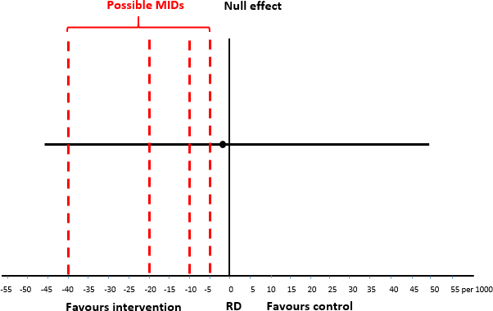

Ameliorating the challenge of choosing an MID, an example from a systematic review
Consider a systematic review evaluating the effect of corticosteroid treatment in patients with sepsis. The systematic review, conducted to inform a BMJ Rapid Recommendation, included 17 RCTs enrolling over 4,000 participants.² It reported a point estimate of 3 additional gastrointestinal bleeds per 1000 patients in those randomized to corticosteroids, with a 95% CI ranging from 5 fewer to 13 more bleeds per 1000 patients
(Figure 4).
Figure 4. An example of rating certainty in little to no effect without prespecified MIDs in a systematic review of corticosteroids in sepsis with relation to gastrointestinal bleeding. If the implicit threshold is close to 10 in 1,000 (MID1) or less, Core GRADE users would rate down for imprecision. If it is in the vicinity of 20 in 1,000 (MID2) they would not.
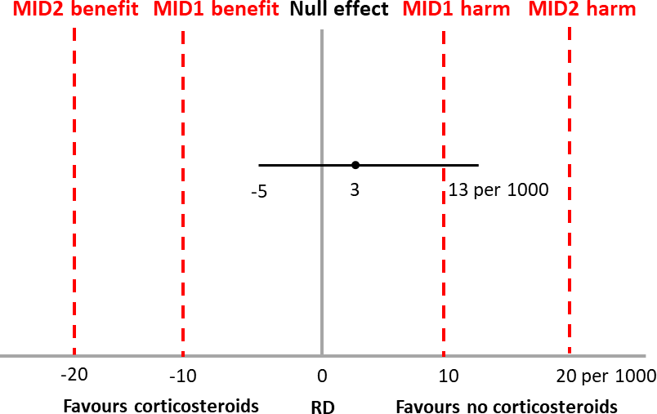

Let us say that the GRADE team had planned to choose the null as the threshold and thus to rate their
certainty in a non-zero effect. They now, however, face a point estimate of an increase of 3 bleeds in 1,000, very close to the null and representing an effect that they consider unimportant. Thus, they choose to rate their certainty in little to no effect.

When doing so, they must consider possible estimates of the MID for benefit and harm. Let us say their
threshold is close to 10 in 1,000 (MID1 in Figure 4). Since the boundary of the CI favoring no corticosteroid is appreciably greater than 10 in 1,000, they lose confidence in their inference of an unimportant increase in bleeding and would rate down for imprecision.
If, however, they believe the threshold of importance is in the vicinity of 20 in 1,000, the boundaries of the CI are appreciably lower than their thresholds and they would not rate down for imprecision. They would conclude that, at least as far as imprecision is concerned, the data provides compelling evidence that
corticosteroids result in little to no increase in bleeding.
This example demonstrates how Core GRADE users choosing the null as the threshold may avoid, when the point estimate is near the null, choosing a single specific value of the MID. In this case, the only judgment review authors need to make is whether the MID is less than the upper limit (harm) of the CI, that is 13 per 1,000 (i.e. 1 to 12 per 1000) or more than 13 per 1,000 (14 or more per 1000). Core GRADE users would rate down for imprecision if they consider the MID less than the upper limit, otherwise not. In describing their decision to rate down or not, authors need to be explicit only in their judgment of whether boundaries of the confidence interval represent important or unimportant effects.

References
- Zeng L, Hultcrantz M, Tovey D, et al. Rating certainty when the target threshold is the null and the point estimate is close to the null. BMJ Evidence-based Medicine (Accepted) 2024
- Lamontagne F, Rochwerg B, Lytvyn L, et al. Corticosteroid therapy for sepsis: a clinical practice guideline. Bmj
2018;362:k3284. doi: 10.1136/bmj.k3284 [published Online First: 20180810]

